FMX Mobile Application Development

Lab Exercise 03.04: Authenticate user against InterBase

Next, now that we have our Login form displayed, we need to enter the Username and Password of our IBlite database to login (authenticate) our Application.
The Iblite database we will be using for our application, has a username ‘staff’ with password ‘password’ that has Read, Write and Update permissions, and a User ‘manager’ with password ‘password’ that has Read, Write, Update and Delete permissions.
Steps:
1. Add | New | Other | DataModule
2. Save DataModule as dmIBlite.
3. On the DataModule, add FDConnection, FDPhysIBDriverLInk and a FDGUIxWaitCursor, like this:
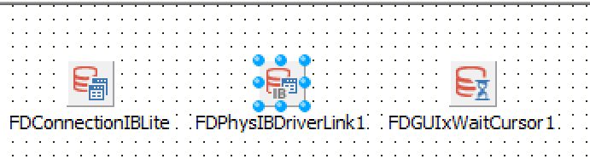
4. Double-click the FDConnectionIBLite component and set its database properties to your IBLite Database, EMBEDDEDIBLITE.IB, like this:
Driver ID = IB
Database = <location of your EMBEDDEDIBLITE.IB database>
Username = SYSDBA
Password = password
Protocol = Local
Server = localhost/gds_db

Note: Locally on Windows, we will be testing and working with the IBLite database using your installed InterBase 2017 Developer Edition.

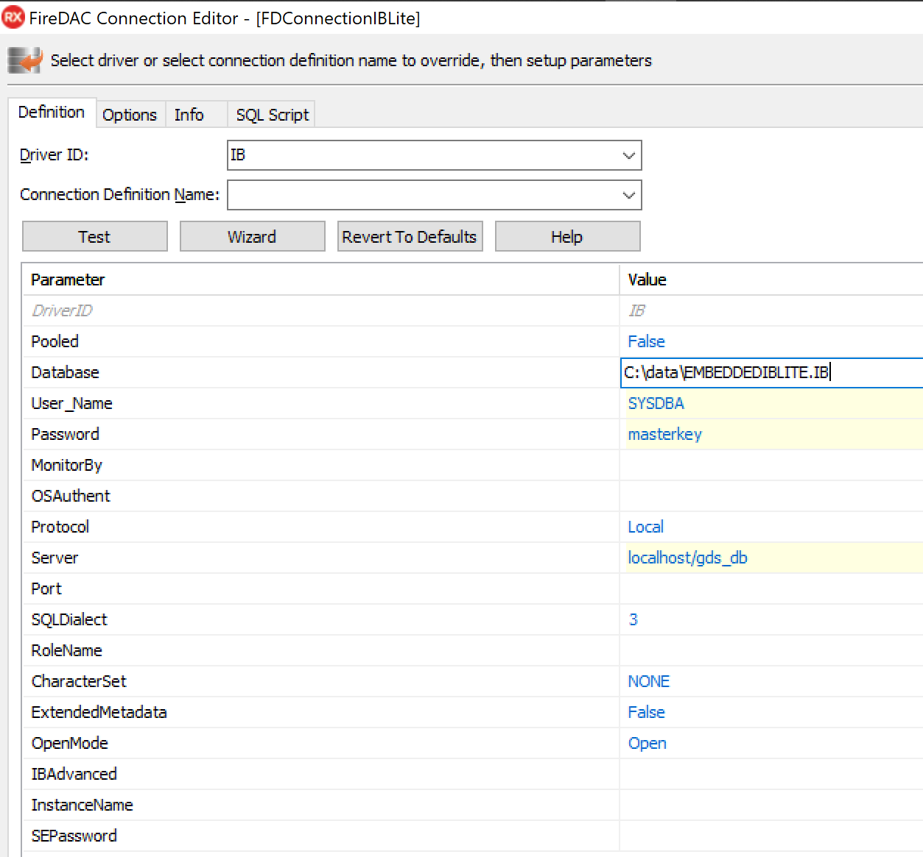
5. Click the Test button, and verify you can connect locally to your EMBEDDEDIBLITE.IB database:
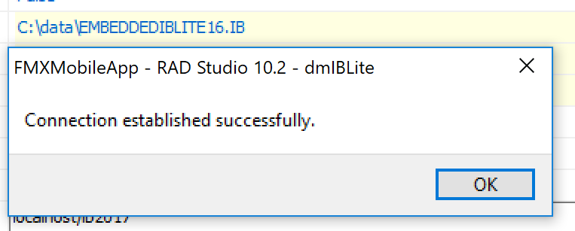
Click OK.
6. For deployment to mobile devices, assure that you have your IBLite.txt license file in your IBREDISTDIR folder: C:\Users\Public\Documents\Embarcadero\InterBase\redist\InterBase2017
7. In the project, create a new Multi-Device Unit called uCamera. We will navigate to this uCamera Form, if we successfully authenticate the user against our InterBase database.

8. On the Login Screen, enter staff for the Username and password for the password.
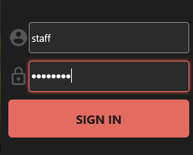
9. To authenticate against the Username and Password for the InterBase database, use this code for the OnClick event of the SIGN IN button:

procedure TForm2Login.LoginFrame21SignInRectBTNClick(Sender: TObject);
begin
LoginFrame21.SignInText.Text := 'Autenticating...';
dmIBLite.DataModule1.FDConnectionIBLite.Params.Values['USER_NAME'] :=
LoginFrame21.UsernameEdit.Text;
dmIBLite.DataModule1.FDConnectionIBLite.Params.Values['Password'] :=
LoginFrame21.PasswordEdit.Text;
try
Begin
dmIBLite.DataModule1.FDConnectionIBLite.Connected := True;
labelLoggedInUser.Text := LoginFrame21.UsernameEdit.Text + ' logged in';
LoginFrame21.SignInText.Text := 'Connected!';
//Hide the Login Screen.
uLoginForm2.Form2Login.Hide;
//Show the next Form, the MultiTabbed Camera Form.
uCamera.Form1.Show;
End;
Except
on E: Exception do
begin
labelLoggedInUser.Text := LoginFrame21.UsernameEdit.Text +
' failed to log in';
LoginFrame21.SignInText.Text := 'SIGN IN';
ShowMessage('Invalid UserName/Password or Connection to IBLite database');
end;
end;
end;

Handling FireDAC Connection Errors
See: http://docwiki.embarcadero.com/RADStudio/en/Establishing_Connection_(FireDAC)
If the FireDAC connection fails, then your application may analyze the failure using one of the approaches:
- using TFDCustomConnection.OnError event handler. This is more appropriate when a connection is opened implicitly.
- using the try ... except ... end syntax. This is the best approach with an explicit connection establishment. For example:

uses
FireDAC.Stan.Consts, FireDAC.Stan.Error;
//...
try
FDConnection1.Connected := True;
except
on E: EFDException do
if E.FDCode = er_FD_ClntDbLoginAborted then
; // user pressed Cancel button in Login dialog
on E: EFDDBEngineException do
case E.Kind of
ekUserPwdInvalid: ; // user name or password are incorrect
ekUserPwdExpired: ; // user password is expired
ekServerGone: ; // DBMS is not accessible due to some reason
else // other issues
end;
end;

